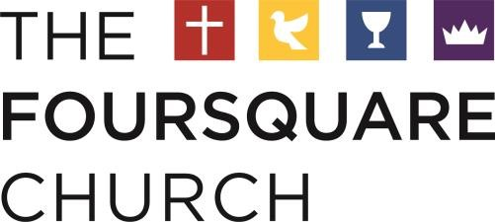

**Public Service Loan Forgiveness (PSLF):**

*9/30/21*

A recent change in the Public Service Loan Forgiveness program may allow those employed by a church (including pastors) to have their subsidized and unsubsidized student loans forgiven. An individual who has made at least 10 years of payments while working full time for a qualified employer is now eligible, according to the [PSLF website](https://studentaid.gov/manage-loans/forgiveness-cancellation/public-service).

The program used to exclude those employed in religious education, worship, or other religious endeavors. However, thanks to a recent court case, religious workers now qualify.

To be eligible for this program, the [PSLF](https://studentaid.gov/manage-loans/forgiveness-cancellation/public-service) notes that:

* You are considered full-time if you meet your employer’s definition of full-time or work at least 30 hours per week, whichever is greater.
* If you work more than one qualifying part-time job, you are considered full-time if you work a combined 30 hours or more between employers.
* Only federal direct loans (also known as William D. Ford Federal Direct Loans) qualify.
* The Federal Family Education Loan Program and the Federal Perkins Loan Program are not eligible, but such loans may become eligible if consolidated into a Direct Consolidation Loan.
* Student Loans from private lenders do not qualify
* The borrower must make at least 120 [qualifying monthly payments](https://studentaid.gov/manage-loans/forgiveness-cancellation/public-service), meaning the payments came after October 1, 2007, under a [qualifying repayment plan](https://studentaid.gov/manage-loans/forgiveness-cancellation/public-service#qualifying-repayment-plans), for the full amount due on each bill, no later than 15 days after each bill’s due date – and while working for a qualifying employer.
* When loans are in “in-school status,” a grace period, a deferment, or a forbearance, the site cautions any payments made are not considered to be qualifying ones.

Although this is excellent news for pastors, it does appear that the program has a backlog of applications, low approval rates, and poor loan service management.

To learn more about this program, please visit the [PSLF Website](https://studentaid.gov/manage-loans/forgiveness-cancellation/public-service). In addition, you may want to set up an account with the [PSLF Help Tool](https://studentaid.gov/pslf/) to see your potential eligibility.